Regression Tests

If you just need to refresh your memory: here’s the checklist. Further down is a more comprehensive tour.

Checklist:

- Create your flow, use a reader/writer combination to store the golden table, use the Differ node to compare test results.
- Remove all writers from the flow.
- Reset all nodes that should be tested.
- Create an owner file with your email address in it.
- Create a workflow_options file (if needed):
  - Add one line for each setting to be changed before execution: for example 1,DataURL,$$locationURL$$/iris.data,String
- Create a node_status file (if needed):
  - Add one line for each node executing with a warning: for example
1,WARN KNIME-Worker-0 File Reader : Model warning message:…
Copy the warning message from the log file (don’t include timestamp)

  - Add one line for each node failing to execute: for example
1,ERROR KNIME-Worker-2 RowID : Missing value found in row…
Copy the error message from the log file (don’t include timestamp)

  - Add one line for each required message: for example
INFO main Calculator: Found 16 columns to be included in…
- Check in the flow (don’t check in the .lock file)
- Run the test again. Make sure it passes.

Introduction:

Regression tests are little workflows to test one node.

You need to checkout „org.knime.testing“ (in the repository under KNIME_Testing).

During test execution all nodes of a flow that are not executed are run. Meaning the regression test flow – at the time of check in – should be in a state where all nodes that should not be tested must be executed and those that should be tested must be executable.

A test succeeds, if at the end all nodes are executed and no error occurred (and no warning icon appears at a node).

Now, in order to test the output of a node add the "Differ" node to the flow (category „Testing“). It has two inputs and compares the two incoming tables during execute. There are different ways of comparing tables (adjustable in the node’s dialog):
- check equivalence; option „TableDiffer".
- compare two ScorerOutputTables with tolerance (this way classifiers fail only when they create significantly different errors during classification; see below). Option "LearnerScoreComparator".
Connect the node-to-test to the “Test Table” input of the Differ, the “Golden Table” input of the node needs to get the correct reference table – the golden table. This golden table must be saved with a TableWriter/Reader combination at testflow creation time. (I admit this is not very comfortable – but there is no better way in the moment.) And: The writer must be deleted before the flow is checked in (otherwise it will be re-executed every time, writing to that (possibly not existing) temp dir).

Example flow (no learner):
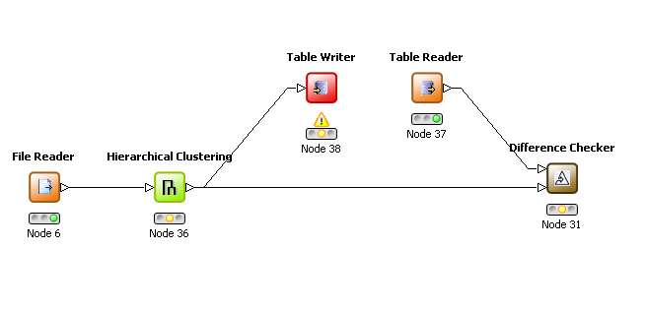Example flow (learner/predictor):
Filereader (executed)
Node under test.
Must be executable.
While preparing the test, save a correct (golden) table in a tmp place. Delete the node before check-in.
Read the correct (golden) table from that tmp place.
Must be executed.
Configure to test the two input tables for equality.
Must be executable.
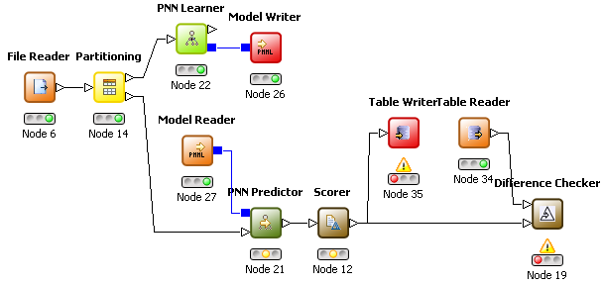
Executed preproc nodes
Writers must be deleted!
Node under test

Disturber node:
Use the “Disturber Node” to test the robustness of your code. This node has one input, three outputs: An output providing the input table, another delivering an empty table, and the third delivers the input table with 10% of the cells replaced by cells with missing values. You could copy the nodes of your flow three times and connect each copy to an output of the disturber, instead of to a file reader, for example. All nodes should be able to gracefully handle empty tables and missing values somehow.

Testing Readers (changing settings in a flow):
In a “workflow_options” file you can specify a new value for a specific option of the nodes. This can be used to set a file location within a reader node and get it tested in the regression system. The file must be located in the root of the workflow (in the same directory as the workflow.knime file), it must be called “workflow_options” and the content is very similar to the “-option” argument of the batch executer:
Each line of the file specifies one new value for a specific setting of one node. The line contains four fields, separated by a comma:
- nodeID: the number displayed below the node icon (e.g. the filereader above has ID 6).
- Name of option: You must examine the settings.xml file in the node’s directory in the workflow dir. In the Config “model” all node settings are stored. Provide the entry key used for the option (or if it is stored in a sub-config, provide the full path to this subconfig, with ‘/’ as separator).
- New value: the new value for the option.
- Type of value: the type of the option’s value: String, int, double, boolean, char, short, byte, StringCell, DoubleCell, or IntCell.
There is support for two variables that can be used in the new value:
$$location$$: occurrences of this pattern in the new value will be replaced by the absolute path to the root of the workflow. With this, you could store a data file in the root dir and let the reader read this file every time the test is run (see example below).
$$locationURL$$: same as $$location$$, but replaces the occurrence with an URL to the workflow location (like “file:/c:/my%20files/…”).
Example: This is a flow to test the file reader node. The table writer for the golden table is already removed from the flow. The file reader is executable in order to be tested. We store a file “iris.data” in the workflow directory (next to the workflow.knime file). We create a “workflow_options” file with one line:

1,DataURL,$$locationURL$$/iris.data,String

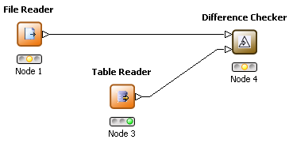
Golden Table (table writer is already removed)
File Reader to test. Data file location is set before flow is executed.

Required Messages and Failing Nodes
To ensure a warning and/or an error appearing in a workflow, or to check for required messages, you can create a “node_status” file (located in the workflow directory (next to the workflow.knime file)). In each line of this file you either specify a node status (the warning/error icon displayed below the node’s icon), or a DEBUG/INFO/WARN/ERROR message that must appear in the log file. If the node does not have the specified status (with the corresponding message), or the specified required message isn’t in the log file, the test fails.
For an expected warning status (after successful execution) add the following line:
<nodeID>,<warning message>
For a required error status (happens after failed execution) add this line:
<nodeID>,<error message>
For each required message in the log file:
<message>
Copy the message that you need to provide here from the log file. Each message must start with WARN or ERROR, etc. (don’t copy the leading timestamp from the logfile).
Example:
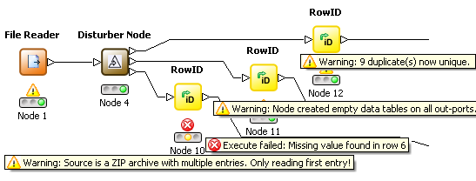
This shows (part of) the already executed test flow. Assume all nodes are reset in the flow that is checked in. One node does not execute, but creates an error message, three nodes execute with a warning, the disturber node executes without warning.
For the File Reader node a workflow_options file like the one from the example above is created.
The node_status file for this flow looks like this:
1,WARN KNIME-Worker-0 File Reader : Model warning message: Source is a ZIP archive with …
10,ERROR KNIME-Worker-2 RowID : Missing value found in row 6
11,WARN KNIME-Worker-3 RowID : Model warning message: Node created empty data tables on … 12,WARN KNIME-Worker-0 RowID : Model warning message: 9 duplicate(s) now unique.
All messages are simply copied from the log file – beginning with the message level, omitting the timestamp at the beginning of the log line. (The dots at the end of the line are not supported; lines are truncated here for a nicer layout.)
If the required message starts with WARN, the node is expected to be executed after the run, if it starts with ERROR, the test passes, if the node is not executed at the end.

Check-in:
Make sure, you’ve deleted the golden table writers from the flow. Before you check in the test flow, add a file called „owner“, which contains the email address of the test owner. Without this, the test won’t be run and an error message occurs. The file must be located in the same directory as the workflow.knime file (in the root of the workflow).
Regression flows are checked in at: „org.knime.testing_testflows “.
All workflows in this or any sub-directory will be executed. Be sure to test (run) the new regression test after check-in.

Running regression tests:
Create a new run configuration for a new Eclipse Application. As program to run choose “Run an application”, and select org.knime.testing.KNIME_TESTING_APPLICATION from the drop-down list. In the “(X)= Arguments” tab, you may want to specify “-ea” as VM Argument (to enable assertions) and “-Xmx1G” (to grant enough memory). If you don’t clear the workspace, a history for the following parameters is maintained.
If you run this configuration, a dialog opens asking for the tests to run.

Testing dialog:
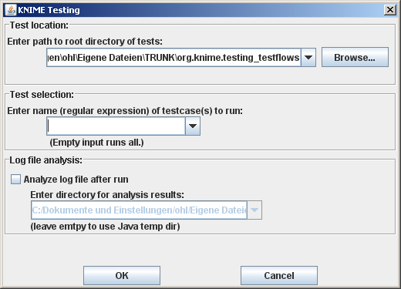
Tests in this dir and any subdir are executed (if they match the pattern).
Only tests matching this regular expression are run.
Example: ‘.*Kmeans’ runs all tests ending with Kmeans

If checked, the log file is analyzed. Parts generated by failing tests are extracted into separate files. A summary file is created.

Enter a directory containing test flows. All tests in that directory or any subdirectory will be executed (if they match the pattern). (If the directory is in your workspace and ends with “_testflows” it will be set as default).
Enter a pattern (regular expression). All tests whose name match the pattern will be executed (".*" runs all tests, ".*Kmeans" e. g. runs the "testKmeans"). Analyzing the log file is only useful if you run many tests (it splits KNIME’s log file into parts, one for each failing test).

To avoid the dialog, specify program arguments in the run configuration:
-pattern <pattern> runs all tests matching <pattern>.
–root <dir> runs all tests in the specified dir or any subdirectory (that match the pattern).
–analyze <dir> analyzes the log file after running the tests and stores the results in a directory in the specified <dir>. If <dir> is omitted the result is stored in the Java temp directory.

Notes:
- If a node should be tested with different settings or different input data you need to create one test for each set of settings/input data. The flows are identical – just the settings differ.
- It is possible to test multiple nodes in one regression test (as all nodes that are executable will be executed) – it’s not advisable though. If one node is broken, there would be many tests failing and it would be hard to figure out which node is actually causing the pain. It’s just harder to debug. Create one test per node. The more the merrier.
- During the regression run the node’s views will be opened before the node gets executed. This is to test the updateModel method. So, there are windows popping up – and automatically closing during the run.

